# MORE QUERIES ON EMPLOYEE DATABASE

**Question**

(**Week6** )

Branch (branch-name: String, branch-city: String, assets: real)

BankAccount(accno: int, branch-name: String, balance: real)

BankCustomer (customer-name: String, customer-street: String,

customer-city: String)

Depositer(customer-name: String, accno: int)

loan (loan-number: int, branch-name: String, amount: real)

* List the name of the managers with the most employees
* Display those managers name whose salary is more than average salary of his employee?
* SQL Query to find the name of the top level manager of each department.
* SQL Query to find the employee details who got second maximum incentive in Febrauary 2019.
* Display those employees who are working in the same dept where his manager is work. ?
* Write a SQL query to find those employees whose net pay are higher than or equal to the salary of any other employee in the company.

**Schema diagram:**

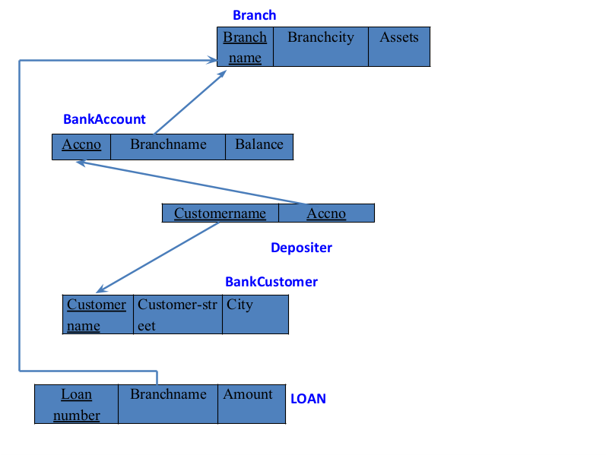

**Create database**

create database employeee11;

use employeee11;

**create table**

create table project(pno int ,pname varchar(30), ploc varchar(30),primary key(pno));

create table dept(deptno int,dname varchar(30),dloc varchar(30),primary key(deptno));

create table employees(empno int ,ename varchar(30),mgr_no int, sal int, nom int,primary key (empno),foreign key(nom) references dept(deptno));

create table assigned_to(empno int, pno int, jobrole varchar(30),foreign key(pno) references project(pno),foreign key(empno) references employees(empno));

create table incentives(empno int references employees(empno) on delete cascade on update cascade, incentive_date date,incentive_amt int,primary key(incentive_date), foreign key (empno) references employees(empno));

**Structure of the table**

desc project;

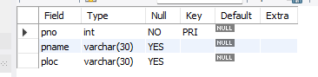

desc employees;

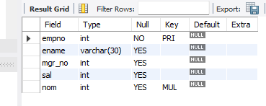

desc dept;

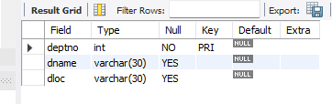

desc assigned_to;

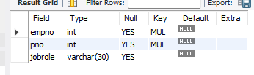

desc incentives;

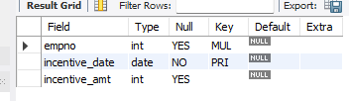

**Inserting values to the table**

insert into project values(101,'AI project','bengaluru');

insert into project values(102,'IOT','hyderabad');

insert into project values(103,'blockchain','bengaluru');

insert into project values(104,'data science','mysore');

insert into project values(105,'autonomous system','pune');

select * from project;

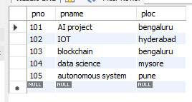

insert into dept values(10,'accounting','mumbai');

insert into dept values(20,'research','bengaluru');

insert into dept values(30,'sales','delhi');

insert into dept values(40,'operations','chennai');

select * from dept;

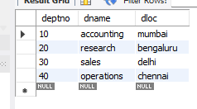

insert into employees1 values(7369,'Adarsh',7902,'2012-12-17',80000,20);

insert into employees1 values(7499,'shruthi',7698,'2013-02-20',16000,30);

insert into employees1 values(7521,'Anvitha',7698,'2015-02-22',12500,30);

insert into employees1 values(7566,'Tanvir',7839,'2008-04-02',129750,20);

insert into employees1 values(7654,'Ramesh',7698,'2014-09-28',12500,30);

insert into employees1 values(7698,'kumar',7839,'2015-05-01',28500,30);

insert into employees1 values(7782,'CLARK',7839,'2017-06-09',124500,10);

insert into employees1 values(7788,'SCOTT',7566,'2010-12-09',30000,20);

insert into employees1 values(7839,'KING',NULL,'2009-11-17',50000,10);

insert into employees1 values(7844,'TURNER',7698,'2010-09-08',15000,30);

insert into employees1 values(7876,'ADAMS',7788,'2013-01-12',11000,20);

insert into employees1 values(7900,'JAMES',7698,'2017-012-03',9500,30);

insert into employees1 values(7902,'FORD',7566,'2010-12-13',30000,20);

select * from employees1;

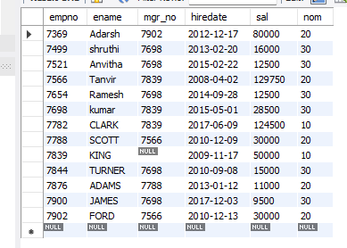

insert into assigned_to1 values(7499,101,"software engineer");

insert into assigned_to1 values(7521,101,"software architect");

insert into assigned_to1 values(7566,101,"project manager");

insert into assigned_to1 values(7654,102,"sales");

insert into assigned_to1 values(7521,102,"software engineer");

insert into assigned_to1 values(7499,102,"software enggineer");

insert into assigned_to1 values(7654,103,"cyber security");

insert into assigned_to1 values(7698,104,"software engineer");

insert into assigned_to1 values(7900,105,"software engineer");

insert into assigned_to1 values(7839,104,"general manager");

select * from assigned_to1;

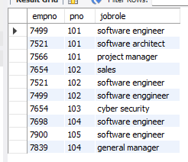

insert into incentives11 values(7499,'2019-02-01',5000);

insert into incentives11 values(7521,'2019-03-01',2500);

insert into incentives11 values(7566,'2022-02-01',5070);

insert into incentives11 values(7654,'2020-02-01',2000);

insert into incentives11 values(7654,'2022-04-01',879);

insert into incentives11 values(7521,'2019-07-01',8000);

insert into incentives11 values(7698,'2019-03-01',500);

insert into incentives11 values(7698,'2020-03-01',9000);

insert into incentives11 values(7698,'2022-04-01',4500);

select * from incentives11;

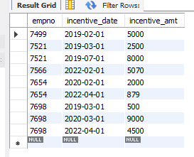

**Queries**

1). List the name of the managers with the most employees

SELECT m.ename, count(*) FROM emp e,emp m WHERE e.mgr_no = m.empno GROUP BY m.ename

HAVING count(*) =(SELECT MAX(mycount) from (SELECT COUNT(*) mycount FROM emp GROUP BY mgr_no) a);

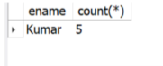

2).Display those managers name whose salary is more than average salary of his employee.

SELECT * FROM emp m WHERE m.empno IN (SELECT mgr_no FROM emp) AND m.sal > (SELECT avg(e.sal) FROM emp e WHERE e.mgr_no = m.empno );

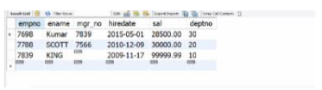

3).SQL Query to find the name of the top level manager of each department.

Select distinct m.mgr_no from e, emp m Where e.mgr_no.mgr_no and e.deptno=m.deptno and e.empno in (select distinct m.mgr_no from emp e, emp m Where e.mgr_no=m.mgr_no and e.deptno=m.deptno));

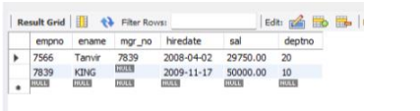

4).SQL Query to find the employee details who got second maximum incentive in Febrauary 2019.

select * from emp e,incentives i where e.empno=i.empno and 2 = ( select count(*) from incentives j where i.incentive_amount <= j.incentive_amount );

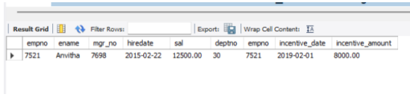

5).Display those employees who are working in the same dept where his manager is work.

SELECT * FROM EMP E WHERE E.DEPTNO = (SELECT E1.DEPTNO FROM EMP E1 WHERE E1.EMPNO=E.MGR_NO);

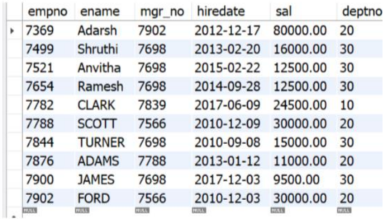

6).Write a SQL query to find those employees whose net pay are higher than or equal to the salary of any other employee in the company.

SELECT distinct e.ename, FROM emp e,incentives i WHERE (SELECT max(sal+incentive_amount) FROM emp,incentives) >= ANY (SELECT sal FROM emp e1 where e.deptno=e1.deptno);

